Agency Brief

Developing and implementing a scalable behaviour change intervention for diarrhoea prevention and treatment for the under-5s, in low-income rural and peri-urban Lusaka Province.
① STAKEHOLDERS
Project stakeholders are; Centre for Infectious Disease Research in Zambia (CIDRZ), Zambian Ministry of Community Development, Mother and Child Health (MCDMCH), Ministry of Health (MOH), Absolute Return for Kids (ARK). Research, behaviour change, intervention design and evaluation guidance is from the London School of Hygiene & Tropical Medicine (LSHTM).
② BACKGROUND
What are the facts about diarrhoea and behaviour change?
Every year, Zambia’s 2.4 million children under five years of age experience over 10 million episodes of diarrhoea; more than 840,000 of these children visit a health facility at least once for diarrhoea, 63,000 will be hospitalised, and at least 15,000 will die. This brief focuses on three behaviours that have been proven to make a real difference to decreasing these distressing statistics:
- Exclusive breastfeeding (EBF) – which means not giving the child other liquids or foods of any sort, up until 6 months of age.
- Handwashing with soap (HWWS) at home after using the toilet or cleaning a child’s faeces; and before preparing food, eating, or feeding a child (the latter to be determined).
- Timely use of correctly mixed and administered oral rehydration salts (ORS) with Zinc for diarrhoea among the under fives.
For us these behaviours are linked to diarrhoea prevention/reduction, but this connection may not exist among our target population and is not necessary for behaviour change to happen.
Humans have not evolved a specific ‘health’ motive and communicating about health rarely initiates healthy behaviours. People the world over often may know ‘the right’ thing to do but still may not do it (think about yourself!) so education and health messaging is not the route we want to go down. We will not talk about death (or saving lives), diarrhoea or disease instead we will be looking at other ways to shift behaviour.
What do we know about these behaviours now?
- Infant feeding behaviour:
Mothers are able to tell you that women should exclusively breastfeed until their baby is 6 months of age, but in reality most EBF for the first month only and then gradually introduce foods (e.g., porridge) and liquids (e.g. Maheu) alongside breast milk after that. This is claimed to be a response to external factors (e.g., having to go to work; wanting to leave child for longer periods, etc.), infant factors (e.g., no longer satisfied with breast milk; interest in food; cries too much, etc.), or mother factors (e.g., sickness including HIV-positive status, although HIV-positive mothers may also be more likely to EBF to prevent transmission to the child; milk supply felt to be inadequate; wanting a fat baby, etc.). Mothers typically continue partial breastfeeding up until almost two years. HIV-positive mothers are encouraged to EBF until 6 months and then stop breastfeeding completely. As we did not conduct research based on HIV-status we do not know the extent to which this is practiced. Practices are influenced by grandmothers and female neighbours.
- Hand cleansing at home:
Hands are almost never washed with soap, usually just water, in the specific target moments we are interested in. Hands may be washed with soap only when heavily soiled.
There’s usually a bucket of water kept outside for laundry or washing dishes that may also be used for HW. Water is almost always available in and around the home. Water is usually obtained from water kiosks, but as payment is required many people also draw water from other (unprotected) water sources such as wells. Water for drinking and cooking is stored in containers inside the home from where it is decanted into buckets and used as needed. Soap (i.e., powder, paste, or bar) often runs out in the course of a day and is kept inside when not in use (i.e., for laundry). The need to do laundry appears to trigger purchase of soap. [See appendix A for images of soaps and water containers.]
Some adult and few child hands are rinsed with water, at the threshold of the home on returning from the toilet. After changing a child, mothers/female caregivers may or may not rinse hands with water only. Before eating the main meal in homes, hands are typically wetted from a special bowl, soap is never used. After eating, hands may be rinsed with the same water. People will say they’ve heard about washing hands after the toilet and most will say that in this moment, if they do it, they use soap.
- Diarrhoea Treatment for Under-5s:
ORS is a known diarrhoea treatment and believed to give the child ‘energy’. There is some very low-level awareness that Zinc is a diarrhoea medicine – and all study participants were interested in it (as they seek medicine to stop diarrhoea), but it is not commonly available.
At home, when a child gets diarrhoea, varying time passes before one of the following is tried:
- ORS (if left over at home or can be borrowed from neighbour) - frequently sub-optimally prepared (wrong water/powder ratio, mixed with still hot water after boiling as most ORS is prepared with boiled water) and administered (not continuously enough);
- Other left-over medicines;
- Traditional medicines;
- Sugar/salt “homemade” ORS (more common in rural and no longer recommended).
If the family judge the child isn’t improving (stops playing, eating and becomes weak) or is getting worse they are taken to the clinic. At the clinic if severely dehydrated they’ll be put on an intravenous drip, if not, a prescription for 1-2 ORS sachets will be given. If the child is moderately dehydrated they may be monitored in an “ORS corner” while ORS is given by the mother. If the clinic pharmacy has run out mothers can buy it from the private pharmacy or return the next day. Zinc is sometimes given although supplies are limited and in rural areas 10 tablet courses may be cut in half (so zinc may not always be prescribed if clinic staff know it is not available). Home: ORS is then (again sub-optimally) administered at home until the child’s energy picks up.
What else do we feel is critical to know?
Life is lived and children are raised across many households: “your neighbour’s child is your child” philosophy. Older infants and children move between households sometimes eating elsewhere, being chided by others, etc. Resources are shared, borrowed, returned or not. TV & radio are seen by more than the people that own them. And the mobile number given to you may be a neighbour’s. Visiting friends and relatives is part of daily life (it is important to visit when someone is ill), as is sharing information and knowledge. In compounds, houses are mostly rented and one lives largely communally, under the eye of neighbours outside, during daylight hours at least. Tenure is precarious and people move house a lot. When they move to a new neighbourhood, it takes time to learn where things are (market, clinic etc.) Money may be accessed across households through Kalimba ‘revolving loans’ although these involve strict rules and can be a source of conflict. Older children also tend to take care of toddlers or babies when mothers are doing household chores.
Status matters: having a child brings a woman status. A well-looked after child (i.e., “a healthy child is a fat child”) confers status through competency as a mother. Information as social currency brings or maintains status. Clinic-workers have status and some abuse it by granting favours, treating people poorly, or disappearing when the clinic is busy.
Responding to the child - their state, energy levels, requests, their rebuttals, likes and dislikes - is one way mothers explain how they work out how to nurture children. When my child cries after breastfeeding – surely s/he is asking for other foods? When my child’s energy returns - surely it’s time to stop giving them ORS? When they look better – surely they are better? This can go beyond ‘responding’ to them to a more visceral connection, “When my child is sick, I am sick”.
‘Hoarding’ even basic household supplies, is not standard practice. Things are bought as needed or when there’s money. Borrowing from neighbours, repurposing (e.g., using left-over drugs to treat a sick child), loans and credit fill resource gaps in emergencies. Having stocks at home could be a stress rather than comfort - if you have surplus it is harder to deny a neighbour’s request to borrow. Despite not hoarding household supplies, people seem to save medicines (in a sense, hoarding) e.g. even ‘free’ ORS or zinc tablets are kept and used sparingly so as not to waste them (e.g., a packet of ORS may be only half prepared, leading to errors in concentration).
③ TARGETS FOR BEHAVIOUR CHANGE
We want to reduce diarrhoea among under-fives in peri-urban and rural low-income households in our Lusaka Province pilot areas. This means changing behaviour among the following groups:
 | 1. EBF | 2. HWWS | 3. ORS + Zinc
Households | Mothers of babies under 6 months who still EBF | All old enough to feed selves from family pot and go to toilet unassisted  Household heads (men & grandmothers) | Mothers of children 1-59 months  Household heads (men & grandmothers)
Clinic staff & health workers | Health workers who promote EBF (?) |  | Health workers, clinicians, pharmacists
Private pharmacies |  |  | Owners, dispensers
Shops, soap sellers |  | Owners
④ INTERVENTION DESIGN PRINCIPLES:
Our aim is to change behaviour (not to purely educate or give messages). The following are guidelines for overall intervention design which will help us do this while in section ⑤ we share specific tasks within each targeted behaviour.
- We do not need our target audience to know that the connection between our three behaviours is diarrhoea prevention/treatment. However, we imagine it would be useful to have a way to connect the three behaviours within a program because it will:
  - Have a multiplier effect where some aspects of the intervention reinforce others;
  - Make the most of our limited resources if we can bundle things together;
  - Make implementation more consistent and coherent for us.
Our first thoughts are that this could be: a message (e.g., ‘My mum when I was young did X, Y, Z and now I’m a big shot’); a vehicle (e.g., a radio drama, an authoritative yet approachable advisor like Donald Winnicott or aspirational figure like Michael Power!); a brand (e.g., Brothers for Life). We will really value your input!
- As a minimum our intervention must not conflict with, but will ideally reinforce existing public health messages for our target behaviours and for diarrhoea.
- Must work for rural and peri-urban settings and be scalable for the rest of Zambia.
- All implementation must work for low/no-literacy communities. ‘Orality’ (thought and verbal expression in non-literate communities) demands emphasis on understanding through observation and imitation, through practice and reflection, through trial and error, through narrative, rhymes, sayings, repetition, signs, etc. Currently, materials in clinics (i.e., posters) and clinic staff’s behaviour (i.e., writing instructions for medicine usage) may not acknowledge this. Successful interventions in non-literate communities often have a highly participatory nature e.g., community-led total sanitation.
- People in our target communities are often used to getting things for free. Health workers and promoters can find it hard to engage people if there is no ‘give-aways.’ But giving stuff away can reduce its perceived value and make an intervention less sustainable.
- New information (e.g., zinc stops diarrhoea) and ideas (e.g., HW stations during behaviour trials) are social currency and - if ‘proven’ through personal experience and/or coming from a high-status source (i.e., clinic) – will often be actively shared. We should see the creation of social currency to help spread messages and behaviours as part of our remit but be aware that being able to say something does not equal doing something!
⑤ (MEASURABLE) BEHAVIOURAL TASKS
Desired Behaviour | Measurable Behavioural Tasks
1. EBF for first 6 months: | - Disrupt existing societal ‘we say we do but we don’t’ (e.g., Angelina Jolie’s double mastectomy created a whole new conversation about breast cancer prevention).  - Address ‘for the poor’ low status image of breastfeeding – e.g., aspirational role models inc. higher-status mothers, clinic workers in community to EBF, etc.  - Piggy- back on existing early intervention- points in early month(s) before the first mouthfuls of non-breast milk are introduced and include fathers and grandmothers – i.e., clinic after birth, 6 day visit, 6 week visit, etc.  - Make EBF feel doable by re-expressing timeframes – e.g. ‘every extra day you EBF’ vs. ‘EBF for 6 months’.  - For key ‘events’ that prompt first non-breastmilk mouthfuls (e.g. baby keeps crying after breast, sore nipples, etc.) find easy, sensible solutions successful EBF mums already use. Spread them in memorable, interesting ways to create a sharable social currency among mothers.  - NB: We think people don’t understand that EBF means anything other than breast milk as some liquids and foods given and may not classify as ‘food’.  - NB: We also know from previous interventions that peer-to-peer support helps but is it scalable.
2. HWWS at home after toilet, or cleaning up a child’s faeces, (and before preparing food, eating or feeding a child): | - Make soap something households don’t run out of – e.g., shop keepers promote the things people should always stock at home  - Have a designated place for handwashing with soap next to water outside the home (site for people to decide) - e.g., build-a-HWWS station competition in schools or community.  - Make washing hands with soap before food and after the toilet good (neighbourly) manners underpinned by disgust - e.g., show a child asking to wash their hands before eating at a neighbour’s home and the neighbour saying something positive to another neighbour about that mother.  - Storekeepers stock and promote low-fragrance soaps for HWWS as soap smell on hands before eating is not liked – e.g., point-of-sale stickers.  - NB. We have some concern that people are unpractised at using soaps for hand washing. We may need to show or model or encourage trial of this as part of what we do.
3. Timely use of correctly mixed and administered ORS & Zinc for under-5s: | Clinics:  - Commoditise prescribing practices:  - Consistently recommend ORS + Zinc as the best first treatment for infants’ diarrhoea after 3 loose stools.  - Give enough ORS and Zinc for whole episode;  - Give correct sized tablets for child based on age;  - Provide physical means for correct ORS dilution (e.g. Kit Yamoy or plastic bag to measure water);  - Mothers give child first zinc tablet at clinic under supervision (by whom tbd)  - Key (missing) behaviours around Zinc + ORS shown and communicated to mothers: correct ORS dilution with drinking water; ORS given continually until diarrhoea stops; Zinc for ten days.  Private pharmacies and other health-workers:  - Consistently recommend ORS + Zinc as the best first treatment for infants’ diarrhoea after 3 loose stools.  Households:  - Establish practice of always having (min 2x full packets) ORS at home – e.g. given out at first visits to clinic (e.g. during 6 week BCG vaccination?) in special hanging bag, health workers do spot-checks with prizes  - Make third loose stool call to action to give ORS now and get to the clinic asap for zinc by tapping into women’s desire to respond to their child’s needs – e.g., ‘one thing your child can’t tell you…’  - Key (missing) behaviours around Zinc + ORS practiced: ORS diluted to right volume with potable water (which if boiled must be cooled); ORS given continually until diarrhoea stops; Zinc once a day for10 days – e.g. Kit Yamoy + shown mini video drama of what to do at clinic on mobile phone.  - ORS + Zinc becomes what people ask for and recommend to others as the best first treatment for infants’ diarrhoea after 3 loose stools – e.g. one pack communicates about the other.

⑥
AGENCY DELIVERABLES & REQUIREMENTS:
The core agency outputs will be:
- Signed off strategy underpinning intervention design – this will specifically help us understand how to manage doing work on three behaviours in communities within the pilot program.
- Signed off overall intervention design.
- Channel/touch-point strategy for execution in both rural and peri-urban locations in Lusaka;
- Development of all materials and interactions associated with this for pilot.
⑦ TIMING & TEAM:
The intervention development process will be led by Jenala Chipungu (CIDRZ) and Katie Greenland (LSHTM). The process and timings and outputs at each stage will be agreed with the agency – and need to fit with baseline measurement, but include the following steps:
Timing | Activity | People
June 7th | Email brief to agency
June 10th | Face-to-Face Briefing | (Val) Katie, Jenala, Zumbe
June 12th | Present to stakeholders
June | Agency community immersions & insight hunting through FR materials
June 14th | Sign off the brief
July | 1st agency response to brief.
July | 1st feedback from client & agree revisions
July | 2nd agency response to brief
August | 2nd feedback from client & agree revisions
August | Final response to brief
August | Sign off by client and implementation plan agreed
August | Pre-testing of materials
September | Implementation training development
September-October | Baseline
October-November | Roll Out

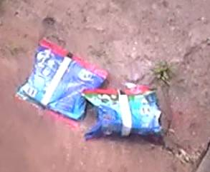
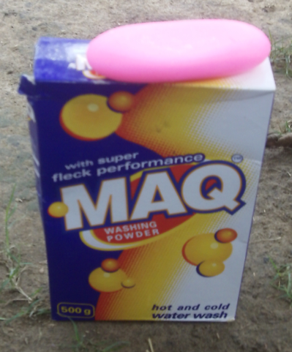
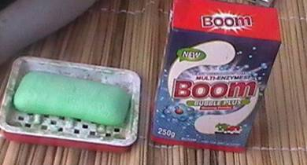
Appendix A: Soaps, Water containers typically found in homes
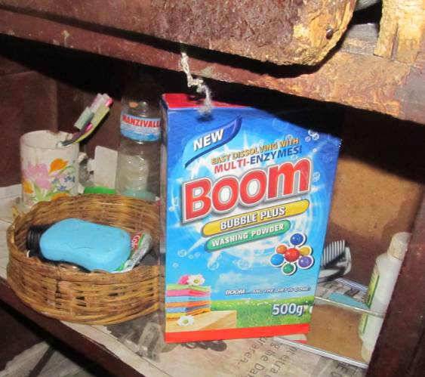
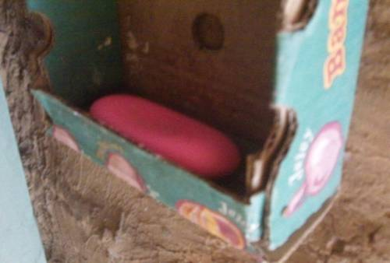
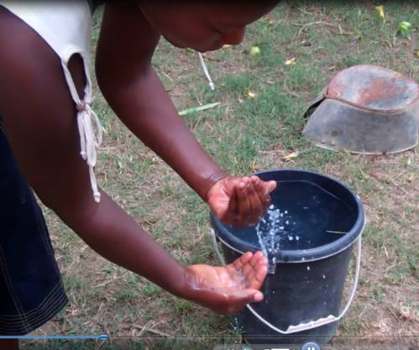
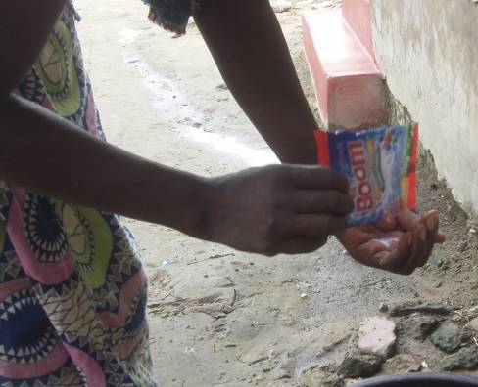
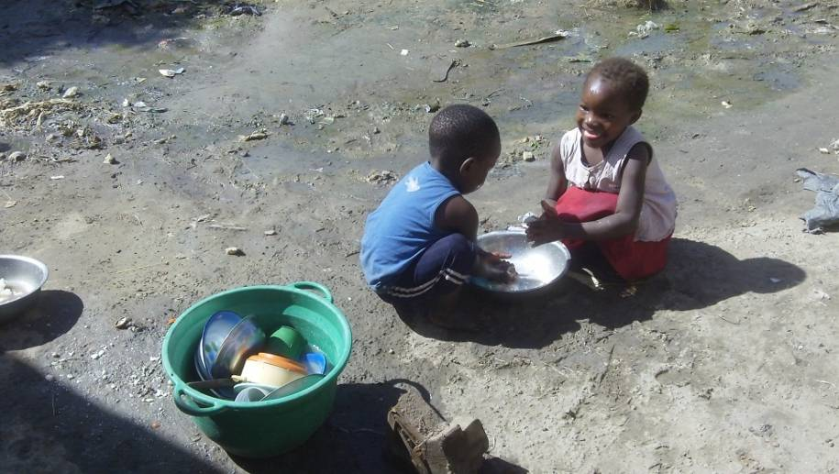
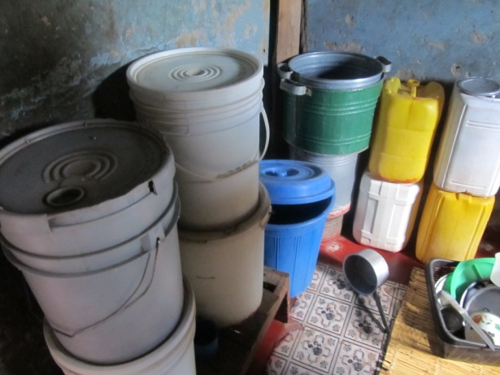
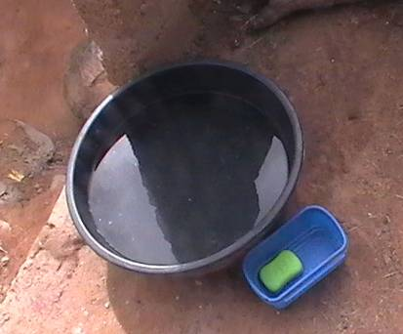
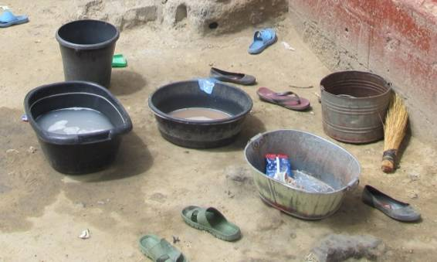

Zinc is largely unavailable in Lusaka Province. Ensuring continuity of supply and access will be essential during the pilot but is not the responsibility of the creative agency.
In depth research reports on the three individual behaviours are available.
CIDRZ can advise on the main messages our target population are likely to be exposed to.
http://www.grandchallenges.ca/grantee-stars/0144-01/

